Enrollment System Modernization (ESM) Phase 2

Veterans Health Information Systems and Technology Architecture (VistA)   
Registration, Eligibility & Enrollment (REE)

DG*5.3*947

Release Notes



October 2018

Department of Veterans Affairs

Office of Information and Technology (OIT)

Table of Contents

1 Introduction 1

2 Purpose 1

3 Audience 1

4 This Release 1

4.1 New Features and Functions Added 1

4.2 Enhancements and Modifications to Existing 1

5 Known Issues 4

6 Product Documentation 4

Table of Figures

Figure 1: MILITARY SERVICE DATA, SCREEN <6> 3

Figure 2: MILITARY SERVICE DATA, SCREEN <6.1> 3

# Introduction

DG*5.3*947 is being released to support the enhancements for the Enterprise Health Benefits Determination (EHBD) program that focuses on updates for the Enrollment System Modernization (ESM) Phase 2 project, which supports Enrollment System Community Care (ESCC).

# Purpose

The Release Notes cover the changes to Veterans Health Information Systems and Technology Architecture (VistA) Registration, Eligibility & Enrollment (REE) Registration (DG) systems for this release. DG*5.3*947 is also being released in support of the Enrollment System (ES) 5.3 release. Refer to Informational Patch EAS*1*165 (Enrollment Application System) for additional details regarding the ES release.

# Audience

This document targets users and administrators of VistA REE, the DG system and applies to the changes made between this release and any previous release for this software.

# This Release

This software is being released as a patch (PackMan) message. The PackMan message includes the DG*5.3*947 patch, which also supports the Enrollment System (ES) 5.3 release.

The following sections provide a summary of the enhancements and modifications to the existing software for VistA REE with the release of patch DG*5.3*947.

## New Features and Functions Added

There are no new features or functions added to VistA REE for DG*5.3*947.

## Enhancements and Modifications to Existing

The REASON FOR EARLY SEPARATION (#.09) field within the MILITARY SERVICE EPISODE (#.3216) multiple within the PATIENT (#2) file is added in Veterans Health Information System and Technology Architecture (VistA) Registration, Eligibility & Enrollment (REE). The data for this field will be received from ES in ORF-Z11/ORU-Z11 HL7 messages in the ZMH segment. The Reason for Early Separation cannot be edited or deleted by VistA users and will not be sent back to ES in a Z07 message.

Note: DBIA 5783 MILITARY SERVICE EPISODE API - DGMSEUTL includes component GETMSE that returns all records in the MILITARY SERVICE EPISODE (#.3216) multiple within the PATIENT (#2) file in the MSE array. While no modifications were made to this component, the REASON FOR EARLY SEPARATION (#.09) field is included in the returned array.

Enhancements and modifications are tracked in Rational Requirements Manager (RM) as follows:

RM # 958405: Add additional data element “Reason for Early Separation” in the ZMH segment of HL7 message

RM # 958406: Display “Reason for Early Separation” in VistA.

RM # 958407: Display the Help Prompt and Help Prompt Description for “Reason for Early Separation” in VA File Manager.

RM # 958408: Figure 1 Screen Mockup - Military Service Data Screen <6>

RM # 958409: Figure 2 Screen Mockup - Military Service Data Screen <6.1> (Add, Edit, Delete – Scenario 1)

**List of Updates**

DG*5.3*947 makes the following enhancements to REE:

1. The REASON FOR EARLY SEPARATION (#.09) field within the MILITARY SERVICE EPISODE (#.3216) multiple within the PATIENT (#2) file is added.
2. The FUTURE DISCHARGE DATE (#.08) field within the MILITARY SERVICE EPISODE (#.3216) multiple within the PATIENT (#2) file is modified to be NONEDITABLE.
3. The HL7 interface with ES is modified to include the additional data element of "REASON FOR EARLY SEPARATION" that is associated with each MSE. The ORUZ-11 message contains a new sequence, (#9), in the ZMH segment for the "REASON FOR EARLY SEPARATION".
4. MSEs that contain a REASON FOR EARLY SEPARATION will not be included in the ORU-Z07 or ORF-Z07 messages sent to ES.
5. The following VistA menu options were modified to display the Reason for Early Separation:
6. View Registration Data [DG REGISTRATION VIEW]
7. Load/Edit Patient Data [DG LOAD PATIENT DATA]
8. Register a Patient [DG REGISTER PATIENT]
9. Eligibility Verification [DG ELIGIBILITY VERIFICATION]
10. Preregister a Patient [DGPRE PRE-REGISTER OPTION]
11. Admit a Patient [DG ADMIT PATIENT]

Note: In the Preregister a Patient [DGPRE PRE-REGISTER OPTION] option, the field is shown only if there are MSE inconsistencies in the record.

1. The VistA REE system displays the Reason for Early Separation on the following screens as view-only next to the caption "Early Separation Reason:" (screen mockups below):
2. Military Service Data, Screen <6>
3. Military Service Data, Screen <6.1>

Figure 1: MILITARY SERVICE DATA, SCREEN <6>

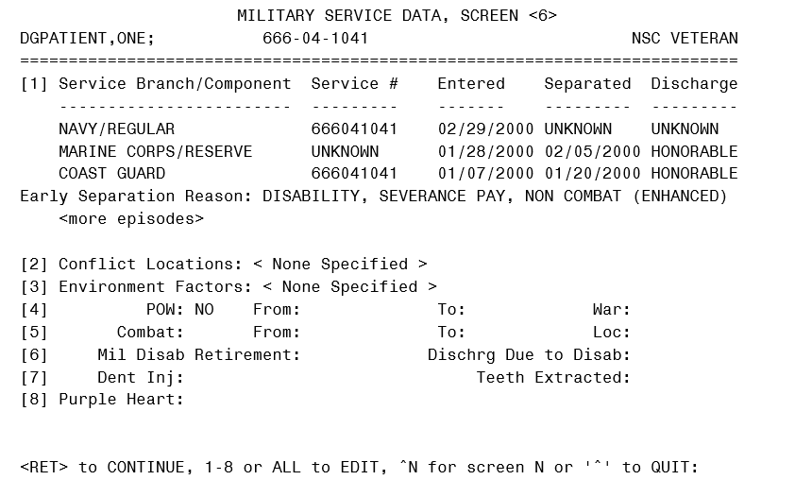

Figure 2: MILITARY SERVICE DATA, SCREEN <6.1>

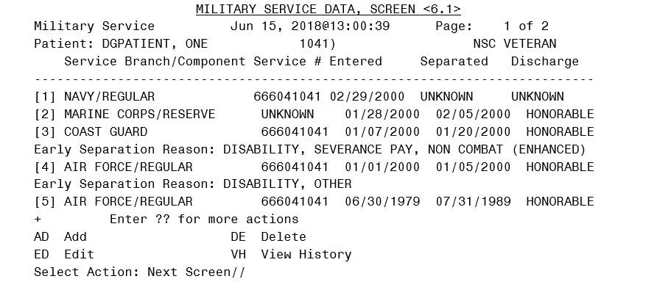

1. The VistA REE system does not display the Reason for Early Separation caption if one does not exist for the MSE.
2. The following VistA menu options were modified to display the Reason for Early Separation:
   1. View Registration Data [DG REGISTRATION VIEW]
   2. Load/Edit Patient Data [DG LOAD PATIENT DATA]
   3. Register a Patient [DG REGISTER PATIENT]
   4. Eligibility Verification [DG ELIGIBILITY VERIFICATION]
   5. Preregister a Patient [DGPRE PRE-REGISTER OPTION]
   6. Admit a Patient [DG ADMIT PATIENT]
3. The VistA REE system does not allow the user to edit an MSE Reason for Early Separation.
4. The VistA REE system does not allow the user to delete an MSE Reason for Early Separation.
5. When the number of MSEs spans multiple pages on screen <6> or screen <6.1>, the VistA REE system displays all the data elements for each MSE on the same page. The MSE data elements to be displayed together include the following: Branch, Component, Service #, Entered, Separated, Discharge Type, and Future Discharge Date or Reason for Early Separation.

# Known Issues

No known issues were identified in this release.

# Product Documentation

The following documents apply to this release:

Title File Name FTP Mode

Release Notes DG_5_3_947_RN.PDF (binary)  
User Manual – Registration Menu DG_5_3_947_REG_UM.PDF (binary)  
Technical Manual – Income

Verification Match IVM_2_TM_RES.PDF (binary)

The preferred method is to retrieve files from download.vista.med.va.gov. This transmits the files from the first available server. Sites may also elect to retrieve files directly from a specific server.

Sites may retrieve the software and/or documentation directly using Secure File Transfer Protocol (SFTP) from the ANONYMOUS.SOFTWARE directory at the following OI Field Offices:

Hines: fo-hines.med.va.gov  
Salt Lake City: fo-slc.med.va.gov

Documentation can also be found on the VA Software Documentation Library at:

<http://www.va.gov/vdl/>